LAMPIRAN E

ANALISIS DATA PENINGKATAN DAYA INGAT

1. Analisis Angket
2. Analisis Hasil *Pretest* dan *Posttest*
3. Analisis Peningkatan Daya Ingat
4. Analisis Hasil Angket

Tabel 13 Data Hasil Angket

|  |  |  |  |  |  |  |
| --- | --- | --- | --- | --- | --- | --- |
| No | Nama | Angket | | | Skor | Nilai |
| 1 | 2 | 3 |
| 1 | Abu | 3 | 3 | 3 | 9 | 100 |
| 2 | Adli | 3 | 3 | 2 | 8 | 89 |
| 3 | Agus | 3 | 3 | 3 | 9 | 100 |
| 4 | Ajang | 3 | 3 | 3 | 9 | 100 |
| 5 | Andita | 3 | 3 | 3 | 9 | 100 |
| 6 | Ane | 3 | 3 | 3 | 9 | 100 |
| 7 | Azzahra | 3 | 3 | 3 | 9 | 100 |
| 8 | Azzam | 3 | 3 | 2 | 8 | 89 |
| 9 | Charista | 3 | 3 | 3 | 9 | 100 |
| 10 | Diki | 3 | 3 | 3 | 9 | 100 |
| 11 | Fajar | 3 | 3 | 3 | 9 | 100 |
| 12 | Indiani | 3 | 3 | 3 | 9 | 100 |
| 13 | Istiqamah | 3 | 2 | 3 | 8 | 89 |
| 14 | Luthfi | 3 | 2 | 3 | 8 | 89 |
| 15 | M. Dikma | 3 | 3 | 3 | 9 | 100 |
| 16 | M. Farhan | 3 | 3 | 3 | 9 | 100 |
| 17 | M. Rizki | 3 | 2 | 2 | 7 | 78 |
| 18 | M. Widi | 3 | 3 | 2 | 8 | 89 |
| 19 | N. Salamah | 3 | 3 | 3 | 9 | 100 |
| 20 | Neri | 3 | 3 | 3 | 9 | 100 |
| 21 | Reyzan | 3 | 3 | 3 | 9 | 100 |
| 22 | Siti Anisa | 3 | 3 | 3 | 9 | 100 |
| 23 | Siti Maryam | 3 | 3 | 3 | 9 | 100 |
| 24 | Wildan | 3 | 2 | 3 | 8 | 89 |
| 25 | Windi | 3 | 3 | 3 | 9 | 100 |
| 26 | Wita | 3 | 3 | 3 | 9 | 100 |
| 27 | Yeni | 3 | 3 | 3 | 9 | 100 |
| 28 | Yusuf | 3 | 2 | 3 | 8 | 89 |
| 29 | Zahra | 2 | 2 | 2 | 6 | 67 |
| 30 | Zahwa | 3 | 3 | 3 | 9 | 100 |
| Jumlah | | 89 | 84 | 85 | 258 | 2867 |
| TOTAL | | | | | | 2867 |
| Persensi angket | | | | | | 96% |

1. Analisis Hasil *Pretest* dan *Posttest*

Tabel 15 Data Hasil Pretest Dan Posttest

|  |  |  |  |  |
| --- | --- | --- | --- | --- |
| No | Nama | Pretest | Posttest | |
| 1 | Abu | 50 | 100 | |
| 2 | Adli | 50 | 100 | |
| 3 | Agus | 10 | 90 | |
| 4 | Ajang | 10 | 80 | |
| 5 | Andita | 40 | 60 | |
| 6 | Ane | 20 | 50 | |
| 7 | Azzahra | 60 | 90 | |
| 8 | Azzam | 50 | 70 | |
| 9 | Charista | 50 | 100 | |
| 10 | Diki | 50 | 80 | |
| 11 | Fajar | 50 | 100 | |
| 12 | Indiani | 50 | 50 | |
| 13 | Istiqamah | 40 | 80 | |
| 14 | Luthfi | 50 | 100 | |
| 15 | M. Dikma | 50 | 100 | |
| 16 | M. Farhan | 50 | 100 | |
| 17 | M. Rizki | 50 | 90 | |
| 18 | M. Widi | 50 | 100 | |
| 19 | N. Salamah | 60 | 60 | |
| 20 | Neri | 50 | 60 | |
| 21 | Reyzan | 10 | 60 | |
| 22 | Siti Anisa | 30 | 80 | |
| 23 | Siti Maryam | 50 | 60 | |
| 24 | Wildan | 50 | 100 | |
| 25 | Windi | 60 | 90 | |
| 26 | Wita | 30 | 70 | |
| 27 | Yeni | 40 | 100 | |
| 28 | Yusuf | 10 | 40 | |
| 29 | Zahra | 40 | 80 | |
| 30 | Zahwa | 40 | 70 | |
| Total | | 1250 | 2410 |
| Rata-Rata | | 41,67 | 80,33 |

1. Uji Normalitas

Tabel 16 Ringkasan Pemrosesan Kasus

|  |  |  |  |  |  |  |  |  |
| --- | --- | --- | --- | --- | --- | --- | --- | --- |
|  | Ket | Cases | | | | | | |
|  | Valid | | Missing | | Total | | |
|  | N | Percent | N | Percent | N | Percent |
| Nilai | Pretest | 30 | 100,0% | 0 | 0,0% | 30 | 100,0% |
| Posttest | 30 | 100,0% | 0 | 0,0% | 30 | 100,0% |

Tabel 17 Analisis Deskripsi Data

|  |  |  |  |  |  |
| --- | --- | --- | --- | --- | --- |
|  | Ket | | | Statistic | Std. Error |
| Nilai | Pretest | Mean | | 41,67 | 2,799 |
| 95% Confidence Interval for Mean | Lower Bound | 35,94 |  |
| Upper Bound | 47,39 |  |
| 5% Trimmed Mean | | 42,41 |  |
| Median | | 50,00 |  |
| Variance | | 235,057 |  |
| Std. Deviation | | 15,332 |  |
| Minimum | | 10 |  |
| Maximum | | 60 |  |
| Range | | 50 |  |
| Interquartile Range | | 13 |  |
| Skewness | | -1,161 | ,427 |
| Kurtosis | | ,264 | ,833 |
| Posttest | Mean | | 80,33 | 3,407 |
| 95% Confidence Interval for Mean | Lower Bound | 73,37 |  |
| Upper Bound | 87,30 |  |
| 5% Trimmed Mean | | 81,30 |  |
| Median | | 80,00 |  |
| Variance | | 348,161 |  |
| Std. Deviation | | 18,659 |  |
| Minimum | | 40 |  |
| Maximum | | 100 |  |
| Range | | 60 |  |
| Interquartile Range | | 40 |  |
| Skewness | | -,495 | ,427 |
| Kurtosis | | -,972 | ,833 |

Tabel 18 Uji Normalitas

|  |  |  |  |  |  |  |  |  |
| --- | --- | --- | --- | --- | --- | --- | --- | --- |
|  | Ket | Kolmogorov-Smirnova | | | Shapiro-Wilk | | | |
|  | Statistic | df | Sig. | Statistic | Df | Sig. |
| Nilai | Pretest | ,307 | 30 | ,000 | ,787 | 30 | ,000 |
| Posttest | ,187 | 30 | ,009 | ,880 | 30 | ,003 |

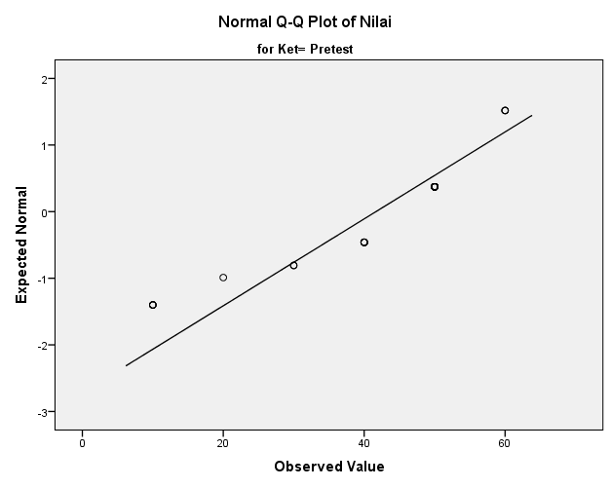

Gambar 3 Normalitas Q-Q Plot data pretest

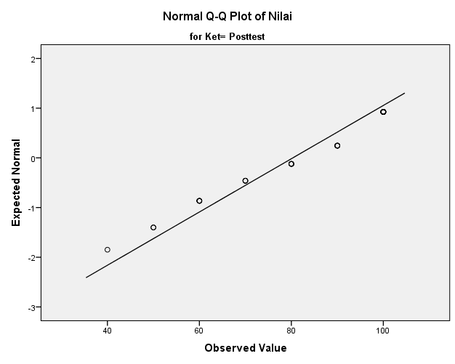Gambar 4 Normalitas Q-Q Plot data posttest

1. Uji homogenitas

Tabel 19 Uji Homogenitas Varians Data

|  |  |  |  |
| --- | --- | --- | --- |
| Levene Statistic | df1 | df2 | Sig. |
| 2,273 | 1 | 58 | ,137 |

Tabel 20 Anova Homogenitas Data

|  |  |  |  |  |  |
| --- | --- | --- | --- | --- | --- |
|  | Sum of Squares | df | Mean Square | F | Sig. |
| Between Groups | 22426,667 | 1 | 22426,667 | 76,907 | ,000 |
| Within Groups | 16913,333 | 58 | 291,609 |  |  |
| Total | 39340,000 | 59 |  |  |  |

1. Uji Man Whitney

Tabel 21 Rank Data

|  |  |  |  |  |
| --- | --- | --- | --- | --- |
|  | Ket | N | Mean Rank | Sum of Ranks |
| Nilai | Pretest | 30 | 17,13 | 514,00 |
| Posttest | 30 | 43,87 | 1316,00 |
| Total | 60 |  |  |

Tabel 22 Uji Data

|  |  |
| --- | --- |
|  | Nilai |
| Mann-Whitney U | 49,000 |
| Wilcoxon W | 514,000 |
| Z | -6,025 |
| Asymp. Sig. (2-tailed) | ,000 |
|  | |

1. Analisis Peningkatan Daya Ingat

Tabel 23 Ringkasan Pemrosesan Kasus

|  |  |  |  |  |  |  |  |
| --- | --- | --- | --- | --- | --- | --- | --- |
|  | Kelompok | Cases | | | | | |
|  | Valid | | Missing | | Total | |
|  | N | Percent | N | Percent | N | Percent |
| NGain_Persen | 2 | 30 | 100,0% | 0 | 0,0% | 30 | 100,0% |

Tabel 24 Analis Deskripsi Data

|  |  |  |  |  |  |
| --- | --- | --- | --- | --- | --- |
|  | Kelompok | | | Statistic | Std. Error |
| NGain_  Persen | 2 | Mean | | 66,94 | 5,836 |
| 95% Confidence Interval for Mean | Lower Bound | 55,01 |  |
| Upper Bound | 78,88 |  |
| 5% Trimmed Mean | | 68,83 |  |
| Median | | 73,21 |  |
| Variance | | 1021,734 |  |
| Std. Deviation | | 31,965 |  |
| Minimum | | 0 |  |
| Maximum | | 100 |  |
| Range | | 100 |  |
| Interquartile Range | | 61 |  |
| Skewness | | -,632 | ,427 |
| Kurtosis | | -,654 | ,833 |