1. **Hasil Uji Linearitas**

|  |  |  |  |  |  |  |  |
| --- | --- | --- | --- | --- | --- | --- | --- |
| **ANOVA Table** | | | | | | | |
|  | | | Sum of Squares | df | Mean Square | F | Sig. |
| Intensi Berwirausaha * Efikasi Diri | Between Groups | (Combined) | 3214.580 | 175 | 18.369 | 4.533 | .000 |
| Linearity | 1575.754 | 1 | 1575.754 | 388.880 | .000 |
| Deviation from Linearity | 1638.826 | 174 | 9.419 | 2.324 | .023 |
| Within Groups | | 68.885 | 17 | 4.052 |  |  |
| Total | | 3283.465 | 192 |  |  |  |

|  |  |  |  |  |  |  |  |
| --- | --- | --- | --- | --- | --- | --- | --- |
| **ANOVA Table** | | | | | | | |
|  | | | Sum of Squares | df | Mean Square | F | Sig. |
| Intensi Berwirausaha * Pendidikan Kewirausahaan | Between Groups | (Combined) | 2599.431 | 143 | 18.178 | 1.302 | .144 |
| Linearity | 1007.874 | 1 | 1007.874 | 72.198 | .000 |
| Deviation from Linearity | 1591.557 | 142 | 11.208 | .803 | .839 |
| Within Groups | | 684.035 | 49 | 13.960 |  |  |
| Total | | 3283.465 | 192 |  |  |  |

1. **Hasil Uji Heteroskedastisitas**

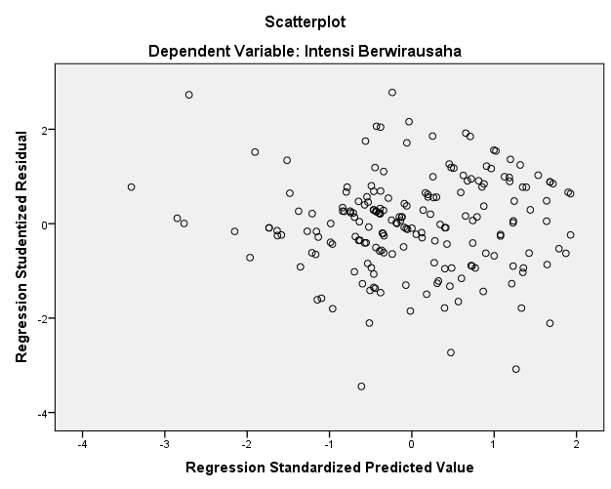

1. **Hasil Uji Normalitas**

**Assessment of normality (Group number 1)**

| Variable | min | max | skew | c.r. | kurtosis | c.r. |
| --- | --- | --- | --- | --- | --- | --- |
| Pendidikan Kewirausahaan | 26.899 | 78.660 | -.118 | -.671 | -.853 | -2.418 |
| Efikasi_Diri | 35.793 | 121.351 | -.356 | -2.021 | .494 | 1.400 |
| Intensi Berwirausaha | 8.444 | 27.798 | .018 | .104 | -.488 | -1.383 |
| Multivariate |  |  |  |  | 1.155 | 1.464 |

1. **Hasil Uji Multikolinearitas**

**Sample Moments (Group number 1)**

**Sample Covariances (Group number 1)**

|  | Pendidikan Kewirausahaan | Efikasi_Diri | Intensi Berwirausaha |
| --- | --- | --- | --- |
| Pendidikan Kewirausahaan | 139.407 |  |  |
| Efikasi_Diri | 123.282 | 254.079 |  |
| Intensi Berwirausaha | 26.982 | 45.546 | 17.013 |

Condition number = 41.002

Eigenvalues

341.338 60.836 8.325

Determinant of sample covariance matrix = 172871.345

**Sample Correlations (Group number 1)**

|  | Pendidikan Kewirausahaan | Efikasi_Diri | Intensi Berwirausaha |
| --- | --- | --- | --- |
| Pendidikan Kewirausahaan | 1.000 |  |  |
| Efikasi_Diri | .655 | 1.000 |  |
| Intensi Berwirausaha | .554 | .693 | 1.000 |

Condition number = 8.055

Eigenvalues

2.270 .449 .282

1. **Diagram Jalur Penelitian**

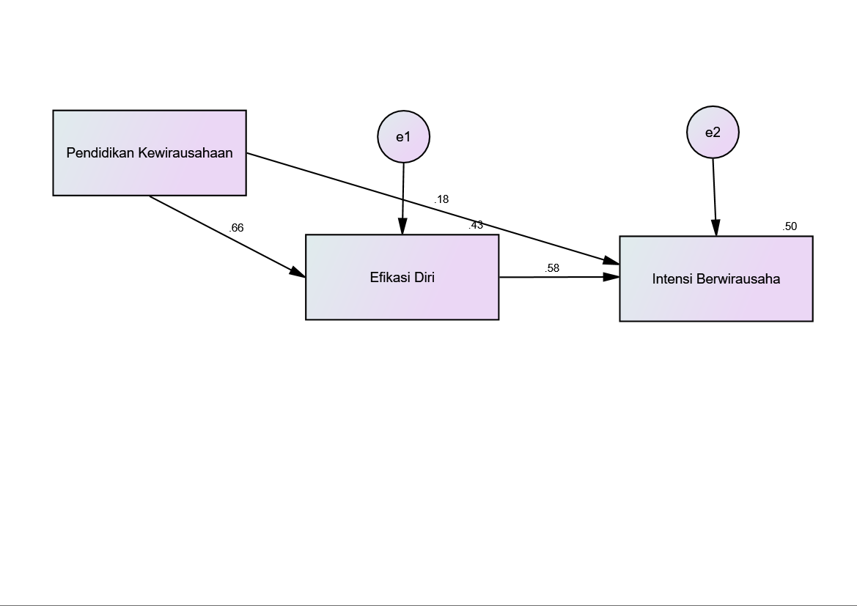

1. **Hasil Analisis Jalur**

**Estimates (Group number 1 - Default model)**

**Scalar Estimates (Group number 1 - Default model)**

**Maximum Likelihood Estimates**

**Regression Weights: (Group number 1 - Default model)**

|  |  |  | Estimate | S.E. | C.R. | P | Label |
| --- | --- | --- | --- | --- | --- | --- | --- |
| Efikasi Diri | <--- | Pendidikan Kewirausahaan | .884 | .074 | 12.013 | *** | par_2 |
| Intensi Berwirausaha | <--- | Pendidikan Kewirausahaan | .061 | .024 | 2.593 | .010 | par_1 |
| Intensi Berwirausaha | <--- | Efikasi_Diri | .149 | .018 | 8.533 | *** | par_3 |

**Standardized Regression Weights: (Group number 1 - Default model)**

|  |  |  | Estimate |
| --- | --- | --- | --- |
| Efikasi_Diri | <--- | Pendidikan Kewirausahaan | .655 |
| Intensi Berwirausaha | <--- | Pendidikan Kewirausahaan | .176 |
| Intensi Berwirausaha | <--- | Efikasi_Diri | .578 |

**Squared Multiple Correlations: (Group number 1 - Default model)**

|  |  |  | Estimate |
| --- | --- | --- | --- |
| Efikasi Diri |  |  | .429 |
| Intensi Berwirausaha |  |  | .498 |

1. **Hasil Uji Sobel**

$$t=\frac{ab}{Sab}$$

Dimana:

**Modification Indices (Group number 1 - Default model)**

**Covariances: (Group number 1 - Default model)**